Civics Unit 1 Study Guide Name: _____________________________
Citizenship and the History of the United States
*This study guide must be completed and turned in on test day, before the test is given. This assignment is worth 25 points.

Unit 1 Agenda (this agenda may change as we move through the unit) & Essential Questions (EQs):
 | Syllabus, Introduction
EQ: What will I need to be successful in this class?

Day 1 | American Identity, Citizenship, Government Structures
EQ: What is the purpose of Government? How is a democracy different from other government structures?

Day 2 | Rights/Duties/Responsibilities, Immigration
EQ: What does active citizenship look like? How does the 14th Amendment define citizenship?
Day 3 | American Revolution, Enlightenment Thinkers
EQ: During the years leading up to the American Revolution, how did people show their discontent with the government? How does the desire for a representative government lead to conflict with and among nations? What effects did the Enlightenment Thinkers have on the colonists?

Day 4 | Declaration of Independence, Common Sense
EQ: What are some similarities between the ideas of the Enlightenment Thinkers and the ideas in the Declaration of Independence?

Day 5 | Articles of Confederation
EQ: What were some of the weaknesses of the Articles of Confederation?

Day 6 | Articles of Confederation, Shays’ Rebellion
EQ: How did the weaknesses of the Articles of Confederation and Shays’ Rebellion contribute to the creation of the U.S. Constitution?

Day 7 |  | Review
Day 8 |  | Assessment

NC Essential Standards included in this unit: 1.1, 1.2, 1.4, 2.5, 3.8, 4.1, 4.2, 4.3, and 4.5
COMPARING GOVERNMENT SYSTEMS AND CITIZENS’ RIGHTS
FP.C&G.1.4 – Analyze the principles and ideals underlying American democracy in terms of how they promote freedom.
FP.C&G.2.5 – Compare United States system of government within the framework of the federal and state structures as well as in how they relate with governmental systems of other nations.
FP.C&G.3.8 – Evaluate the rights of individuals in terms of how well those rights have been upheld by democratic government in the U.S.
FP.C&G.4.1 – Compare citizenship in the American constitutional democracy to membership in other types of governments.
Are citizens’ rights limited, somewhat limited or unlimited? (Think about: right to privacy/civil liberties, responsibilities, political rights/due process, equal protection under the law, participation in government, etc.) Write “limited”, “somewhat”, or “unlimited” in the boxes provided and explain.
Government Systems | Limited, somewhat limited, or unlimited? | How? (Explanation, examples, etc.)
1. Republicanism
(Representative Democracy)
2. Direct Democracy

3. Federalism

4. Absolute Monarchy

5. Limited Monarchy/
Constitutional Monarchy
6. Authoritarian/Dictatorship

Rights, Duties & Responsibilities of Citizens
FP.C&G.4.3 -- Analyze the roles of citizens of North Carolina and the United States in terms of responsibilities, participation, civic life and criteria for membership or admission.
Rights | Duties | Responsibilities
7. Definition: | 8. Definition: | 9. Definition:
10. Examples: | 11. Examples: | 12. Examples:

Civics & Citizenship
FP.C&G.4.5 -- Explain the changing perception and interpretation of citizenship and naturalization.
15. Define Civics:

16. Define Citizen:

17. Citizen by birth – Identify the 2 ways one can become a citizen by birth:
A:

B:
18. Define Naturalization:

19. How does the 14th amendment define citizenship?

20. List 4 influences on American Democracy

21. List 4 more influences on American Democracy

22. Contrast the melting pot and salad bowl theories.

23. Are these theories appropriate to describe America today? Why or why not?

24. List 6 weaknesses of the A.O.C.

25. How are the rights of legal immigrants/aliens different from those of illegal immigrants/aliens?

HISTORY AND FOUNDATIONS OF GOVERNMENT IN AMERICA
FP.C&G.1.1 -- Explain how the tensions over power and authority led America’s founding fathers to develop a constitutional democracy.
26. What was the British economic policy of Mercantilism?

27. What was the role of the American colonies in this system?

28. What was the unofficial British policy of salutary neglect?

29. What is the importance of Shay’s Rebellion?

30. Put these on chronological order: Boston Massacre, Pro of 1763, Stamp Act, Intolerable Acts, Boston Tea Party, Declaration of Independence, Common Sense

31. List 5 characteristics / traits of an American colonist in 1750.

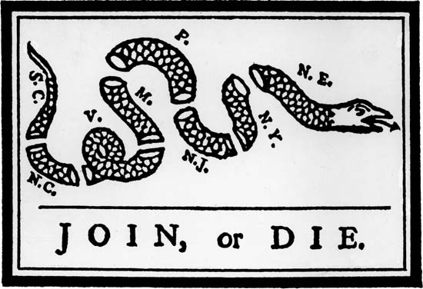
32. What was the significance of Benjamin Franklin’s Join or Die political cartoon?

33. What laws/regulations/acts were put into place in the colonies as a result of the French & Indian War?

34. How did the colonists show their discontent with these laws/regulations/acts?

35. What was the significance of the phrase “no taxation without representation”?

36. List 3 things a legal alien cannot do.

37. What was the significance of Thomas Paine’s Common Sense?

38. What type of government did the Articles of Confederation establish?

39. The colonists feared a strong central government because of their experiences under British rule. In what ways, do we see evidence of this in the Articles of Confederation?

Foundations of America’s Constitutional Democracy
FP.C&G.1.2 -- Explain how the Enlightenment and other contributing theories impacted the writing of the Declaration of Independence, the US Constitution and the Bill of Rights to help promote liberty, justice and equality.
FP.C&G.4.2 -- Explain how the development of America’s national identity derived from principles in the Declaration of Independence, US Constitution and Bill of Rights.
40. What is the significance of the Magna Carta?

41. How do we see evidence of this in the U.S. today?

42. What is the significance of the English Bill of Rights?

43. How do we see evidence of this in the U.S. today?

44. What was the purpose of the Declaration of Independence?

45. Find an excerpt from the Declaration of Independence that promotes Locke’s idea of the social contract.

46. Find an excerpt from the Declaration of Independence that promotes Locke’s idea of natural rights.

47. Find an excerpt from the Declaration of Independence that promotes Rousseau’s ideas of social contract and equality.

Enlightenment Thinker | Views on Government
48. Thomas Hobbes

49. John Locke

50. Jean Jacques Rousseau

Unit 1 – Key Understandings:
- An active citizen participates in government to bring about positive political change.
- Philosophical theories often influence a nation’s political documents.
- People develop systems to manage conflict and create order.
- Democratic societies must balance the rights and responsibilities of individuals with the common good.

